MANCHESTER AND DISTRICT WALKERS (MR50)

COMMITTEE MEETING

9th April 2025, 18.30

AGENDA AND REPORTS

Agenda item | Requested by
- Welcome | ES
- Apologies | LE
- Acceptance of minutes from previous meeting. | All
- Fixing future meeting dates | ES / M
- Junk emails?? | JB / LE
- Walk Ratings | MD
- committee@ email address.  Can we do a check on who receives emails to the committee@ address as it seems like we don't all get them, which makes it tricky to figure whether the appropriate people can pick it up.  I'm proposing to keep the stats section of my report brief (as I have done this month) from now on, unless the general consensus is that the detail provided previously is genuinely useful. | KC

Outstanding actions from last meeting:
Edale MR Donation
Action NM to approve, is £250 appropriate based on funds?
Action KC gofundme to set this up/post on fb.
Next of Kin info
Action LE to post on FB about ICE cards and how to add emergency contact on your phone.
Action RP/ES to agree process for inputting next of kin on a form and what we would then do with that information.
Incidents on walks
Action MD to update walk leaders on what to do in the case of an incident.

Ongoing Actions
Action / Description
Women’s walk leader training – navigation training organized for Sat 16th March in Staveley. Limited numbers, but with idea that those who attend are new to navigation and bring back to the group what they have learned through walks and socials. (Separate to this, interesting to see a few navigation-focused socials on the calendar). ES to put on calendar once date confirmed.
Then ES/MVDZ to put on a walk leader training walk. ES - Idea to also do a navigation/walk ideas social – talk about routes/maps/navigation questions at a pub/bar (quiet enough to talk) in central Manchester – ONGOING (after training)
Walk leader training open to all. ES to ask Margaret about whether we can get funding/top-up from area funding - ONGOING

Young Ramblers weekend – SK and sub-committee met end of last year, started getting quotes. Date to be confirmed, but probably June/July.
Payment expected? Who else is on the committee? Action ES to check with SK, and get someone from the committee added to their whatsapp group.
Ramblers insurance – MP wrote a comprehensive summary of what her interpretation is of the rules, and summary is, it doesn’t apply. Action ES to check with Area.

ACTION 9 ES to check what we should / can minute on confidential matters – ongoing

ACTION 11 ES to get update from Joanna and Ed on footpath maintenance / volunteering. KC got some information from the BMC. Fix the fells (lakes) easier to do invasive clearance and moss planting than footpath maintenance. We could either organise a MAD specific thing, or use the calendar from a website of an organisation, and arrange a social. Don’t touch newts. Action ES.
ACTION 12 refresh the member stories on the website. JB to do a facebook callout.

REPORTS

Chair (Ellie)
Hello MAD walkers,
On Sunday 16th March, six members of MAD attended a navigation training course, led by Navigation with Harriet. The course covered the foundations of navigation, providing skills and confidence in navigating in the outdoors. Ideas/plans are in the works to provide further socials/opportunities to practise navigation skills and share what has been learnt, so watch this space.
The last few months have been filled with an array walks, socials and weekends, with only, I am sure, more to follow as the warmer months and longer days arrive.

Secretary (Lottie)

Not much to report, its been a fairly quiet month for my secretary duties, thanks to all for your reports.
Realised we were missing some info from the previous committee, regarding the prizes we gave out at the AGM but got it sorted now, but if anyone who won reads this, then you have until August to claim.

Walks Co Ordinator (Mike & Kim)
The months of February and March saw 27 walks, led by 19 different walk leaders. This included Marta Lopez and Nicky Cooil leading their first walk, alongside our many regulars. We also started the Sunday Stroll regular easily accessible walk, which has proved to be popular and something we hope to continue through the year. Most of the walks were circular and rated moderate, while 81% were accessible by public transport. We continue to see a great variety of walks, with ratings from Very Easy to Strenuous and Scrambles, while distances range from 2.7 miles to 23.1. According to the walk descriptions, the total distance covered was 286.9 miles with 12478 meters of ascent.
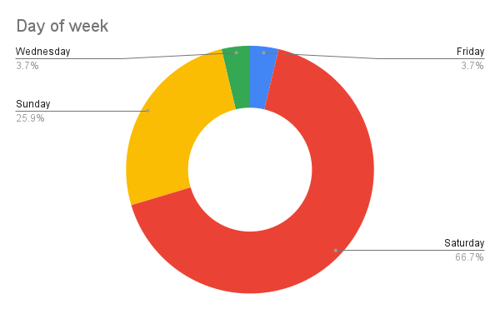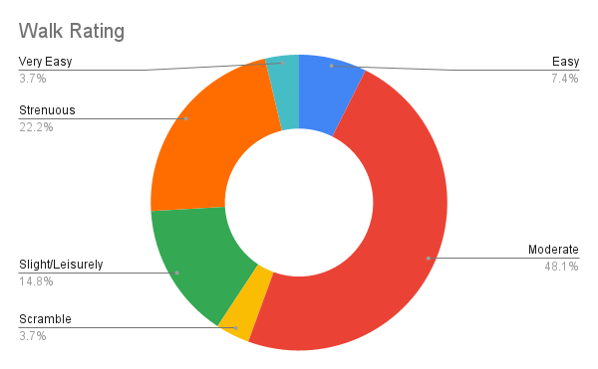
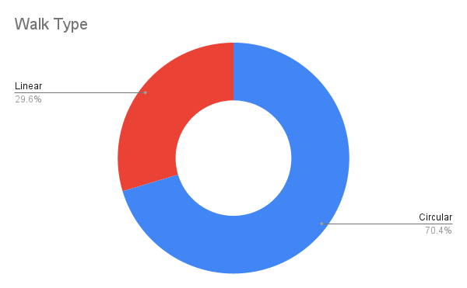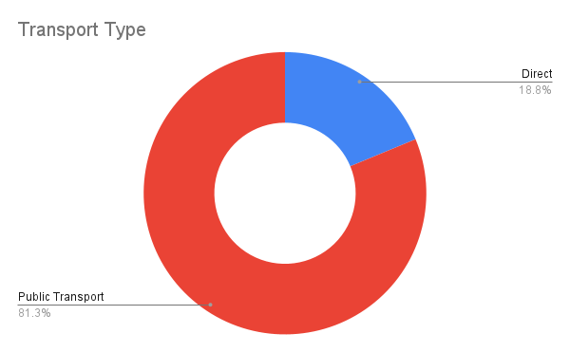

Membership Secretary (James)
According to the Ramblers Membership Insight Hub, as of 06/04/2025 we have 637 members. Since 06/01/2025 there have been 53 new members and 3 are showing as having re-joined.

The are currently 375 members of the MAD Walkers Members facebook group and it is proving to be simple to verify requests from people to join once they are showing on the Ramblers membership list. This is usually the next working day after they have paid.

Around 25/03/25, I emailed using Mailchimp everyone who signed up for our walks since January and indicated on the form that they were not a member. From the report provided by Mailchimp, just over 50% read the email within a couple of days. I will seek advice from the Webmasters to attempt to keep the emails from people’s junk folders.

Treasurer (Natalie)
See below extract from the accounts updated 06/04/2025. The total currently stands as £4,006.98
Now that we have access to the bank accounts, we have caught up on the previous outstanding payments. Additional activity in the last 2 months have included:
- Navigation Training (March) - this used the remaining donated funds, as well as an agreed top up from the MAD balance.
- Helvellyn Weekend (April) - has just concluded so in the process of arranging payments to cover the remaining costs (food etc.).
- Future weekends - accommodation deposits have been paid for both the Glencoe and New Years Llanberis weekends. Both these weekends are higher in cost, but have been carefully reviewed by myself, weekend coordinator and the hosts. Attendee sign ups/deposits will be later this year - but before any other accommodation payments are due.

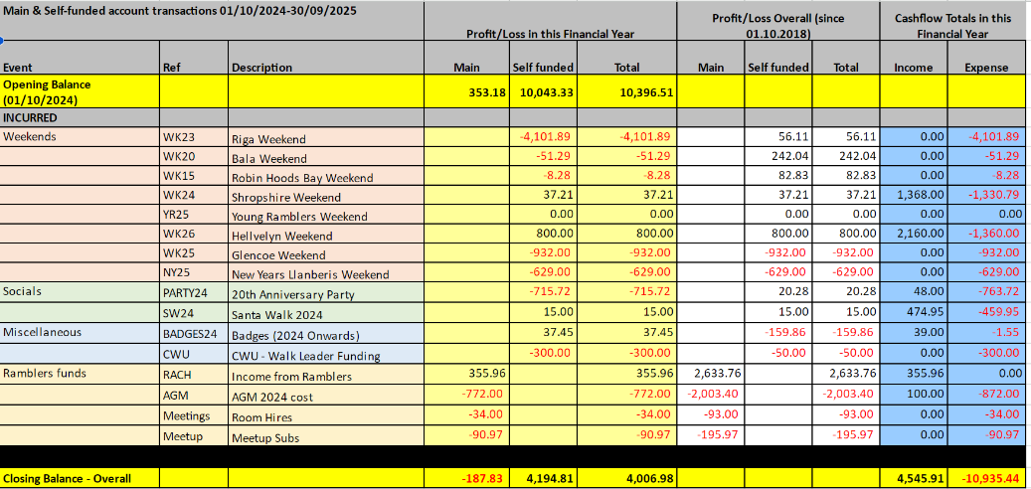

Social Secretary (Chip)
We've had a wide range of socials since the last committee meeting and I am very grateful to everyone who has led socials over the last few months. Currently working on a location for the summer BBQ and just waiting on a response from a potential venue to work out what dates are available to us - current dates being discussed are ones with nothing on the MAD calender (31/05, 14/06, 19/07). There has been a bit of a lull in the suburban socials but hoping that with the weather picking up we will see some arranged. Additionally the social calender for the next month currently looks a bit sparse so would be good to try and encourage some more events.

Communications And Social Media (Katie and Ed)
Here's my report for the April meeting:

No issues to report. Noticeably fewer messages to FB and Insta compared to the beginning of the year, though it does seem like we're getting a few more queries via email (often about dogs, meeting location or cancelling a walk sign up).

Thinking of doing a thank you post to the regular posters on the FB members page, as we rely on those photos for content for the public channels.

Follower numbers - changes since last report
- Instagram: Increased from 2595 to 2662
- Facebook (public): Increased from 5557 to 5586
- Facebook (members): Increased from 362 to 375

Not for the report but a couple of things I'd like to bring up at the meeting:

Thanks

Katie

Webmaster (Desi and Rob)
We have identified and fixed a few issues with booking forms, particularly relating to capacity-limited walks. These were not linking properly and required manual correction; we believe we have now resolved this.
We have also made a few changes as requested, such as to the email copy sent to walk leaders.
We do have outstanding actions from the previous meeting (e.g. collecting ICE details) but these require further discussion.

Best regards,
Desi & Rob

Weekends Co Ordinator (Miranda)

